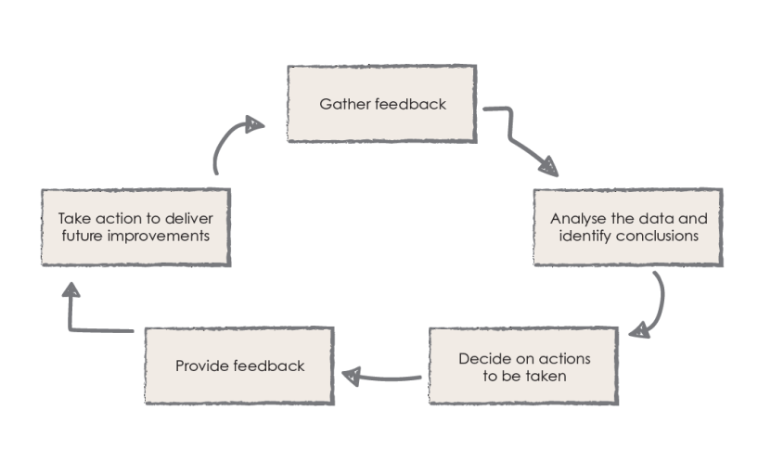
Parent Partnership

We asked:
What are your views regarding transition?

You replied:
- My child moved through the school with high self-esteem
- The prospectus is useful
- Mrs Gilbert (SENco) and the class teacher have supported me through transition
- Meeting the new teachers in early Autumn is reassuring and informative
- The FSW has helped to liaise with different agencies
- Moving to High School has been an unsettling experience

Action:
- Seek out feedback from parents who leave mid-year
- Very useful feedback from parents passed to next school
- Continue curriculum mornings
- Arrange an informal meet and greet in July
- Update prospectus regularly and distribute to new parents depending on key stage
- Seek to strengthen relationships with Year 7 staff in a greater number of schools.

(8.6)

YOUR CHANCE TO SHINE

