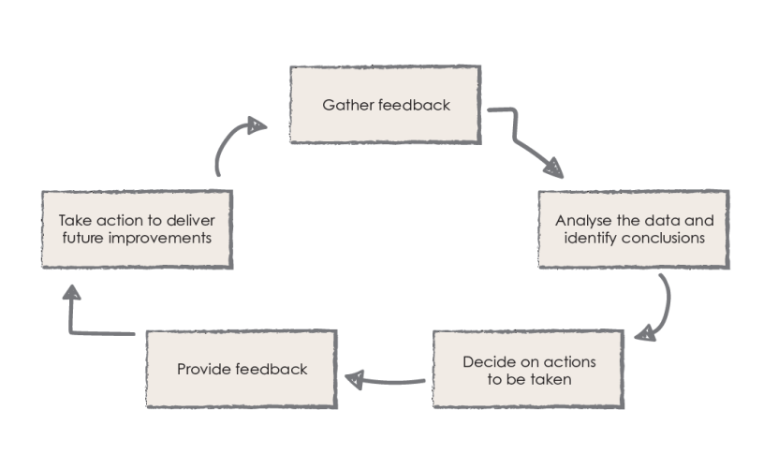
Parent Partnership

We asked:
Are you invited to join us in school to learn with your children?
Are you aware or have you taken up opportunities to develop your own learning?
You replied:
- I have enjoyed coming into school. It’s good!
- It helps me to know how I can help my child
- I’ve been into school to share lessons with my child and to a workshop after school
- I’ve done a course so that I can help others
- Can we have ‘Inspire’ back
- I don’t know where to go for courses

Action:
- Inform the staff of the positive feedback we received on this matter and the importance/consistency of collecting feedback is embedded by all.
- Teachers to make links demonstrating the invaluable support parents can offer us.
- Teachers to consider how after school clubs could engage parents
- Direct parents to others that have knowledge and skills that they may benefit from.
- ‘Inspire’, was a session that we offered half termly, where parents were welcomed into class to support their children’s learning. Parents will be invited to ‘outdoor’ sessions for the remainder of this academic year. Inspire sessions will be formally timetabled and shared in September.

- Signpost courses and workshops on the website that are available locally.
(4.8)

YOUR CHANCE TO SHINE

