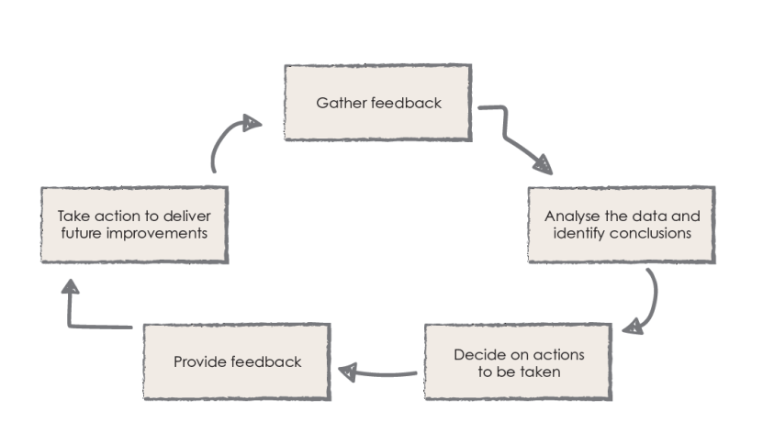
Parent Partnership

We asked:
Are you aware of the policies and procedures we follow and deliver to improve attendance, punctuality, progress and positive participation at Hall green?

You replied:
- They are there to keep everyone informed.
- The ones I have looked at have been useful.
- I can understand the information you provide, if I don’t I ask the teacher
- 20% of parents showed an interest in being part of the review process 80% were happy to leave it to LA and employees.

Action:
- Policies are ratified by governors on a rolling review – parent governors are on the governing body.
- Create a working party to review key policies and ensure clarity.

- Overview of rewards is on the website (feedback – Rewards and Awards)
(7.9)

YOUR CHANCE TO SHINE

