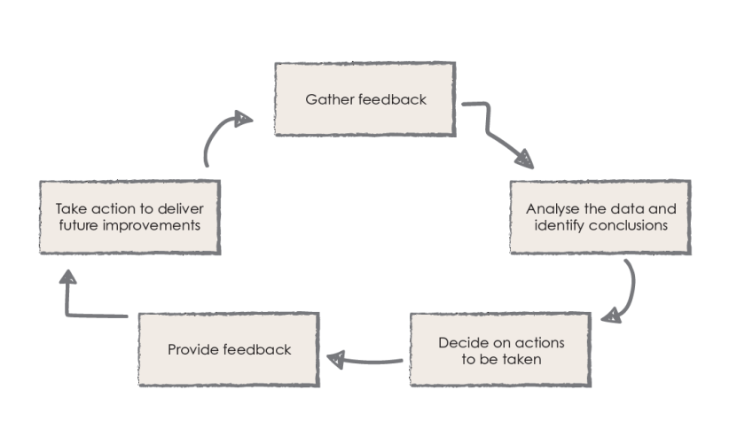
Parent Partnership

We asked:
Does our school provide a good induction for all new parents?

You replied:
- I felt well informed
- We had a meeting with staff
- Most information was verbal but I was able to ask questions so I preferred that
- In nursery we got a pack of information
- I had a home visit and met the family support worker

Action:
- Create a checklist so that inductions are consistent regardless of the staff involved
- Create a prospectus aimed at older children and not just EYFS
- A tracker has been created so we can log attendance and pursue parents who are reluctant to engage.
- Liaise and follow up with parents after induction


(5.8)

YOUR CHANCE TO SHINE

