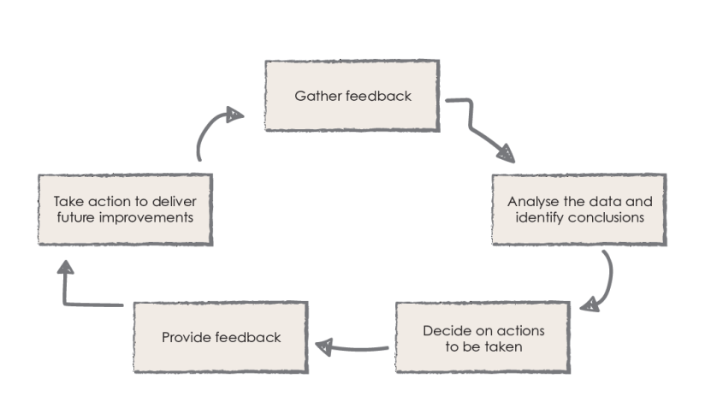
Parent Partnership

We asked:
Is the information we provide: relevant, user friendly and does it enable you to support your child?

You replied:
- The information you provide is clear to understand
- The start of year meeting is helpful to know what’s happening and what is expected of my child
- The reports you give out are personal but the colour coding confuses me.
- If I didn’t understand something I would ask the teacher
- Home learning sheets could be changed

Action:
- Ensure all documentation is free of jargon.
- Inform parents that staff are available to explain and clarify any information they receive.
- Feedback to Senior Leaders as to the colour coding on reports, and how to explain this to parents.

- Home Learning sheets were initially provided as a guide for working at home, however some parents might take this as a literal/prescribed guide, inform them that their support is gratefully received and should be undertaken in a way that suits their own family dynamic.
(6.8)
YOUR CHANCE TO SHINE

