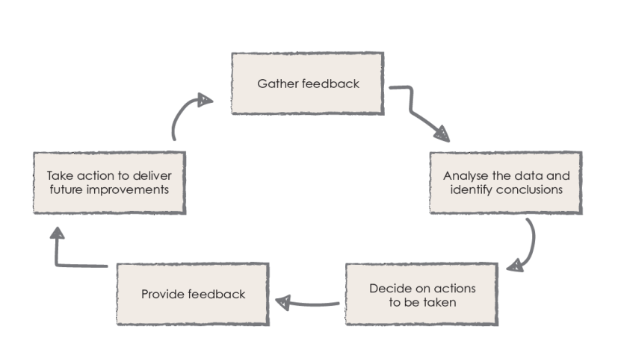
Parent Partnership

We asked:
Is the school a welcoming, communicative and friendly place for parents?

You replied:
- Very welcoming
- Clean and tidy
- Great to see staff daily
- Everyone is approachable and accessible
- Texts are great for sending reminders but consider timings

Action:
- Inform the staff of the positive feedback we received on this matter.
- Ensure that our staff continue to be polite, friendly and professional at all times.
- Feedback to staff regarding the text message service – agree the times we send them (dependent on the message).
- Consider linguistic diversity to communicate with all stakeholders
- Review the methods we use to collect data

(3.9)

YOUR CHANCE TO SHINE

